Asymmetric catalysis with dynamic and chirally-amplified supramolecular polymers

Asymmetric catalysis is the privileged route towards enantiopure compounds. The classical methods involve an enantiopur ligand (in metal catalysis) or an organic molecule (in organocatalysis) to induce a chiral bias to the chemical reaction. In sequential transformations, such as cascade and polymerization reactions, chirality control relies solely on the catalyst or growing chain, i.e. chirality induction occurs in a monodirectional and static fashion.^{[1]} An obvious breakthrough would be to perform asymmetric transformations by means of a catalyst that can be switched reversibly in between different configurations, i.e. a multidirectional and dynamic catalyst. We recently located metallic centres (Rh, Cu) at the periphery of homochiral supramolecular helices in order to perform asymmetric catalytic reactions (hydrogenation, hydrosilylation). These supramolecular helices are formed by self-assembly in solution of structurally-simple monomers derived from an ubiquitous synthon: the benzene-1,3,5-tricarboxamide moiety.^{[2]} The chirality is efficiently transferred to the intrinsically achiral metal centres and allows to reach high enantioselectivities in catalytic reactions of reference.^{[3]} Switching the handedness of the helices in situ allows real-time control of the selectivity: the configuration of consecutively formed stereogenic centres can be selected.^{[3c, 3d]} Finally, our recent results indicate that the extent of chirality amplification can be greatly enhanced in BTA helices by subtle modification of their structure allowing homochiral helices and catalysts to be achieved with minute amount of chiral species.^{[3f]}

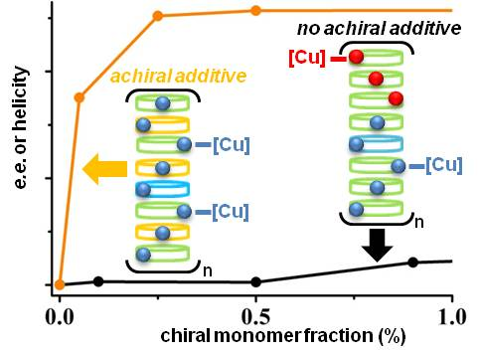
[1] M. Vlaktović, B. S. L. Collins, B. L. Feringa, Chem. Eur. J., 2016, 22, 17080.
[2] S. Cantekin, T. F. A. de Greef, A. R. A. Palmans, Chem. Soc. Rev., 2012, 41, 6125.
[3] (a) M. Raynal, F. Portier, P. W. N. M. van Leeuwen, L. Bouteiller, J. Am. Chem. Soc., 2013, 135, 17687. (b) A. Desmarchelier, X. Caumes, M. Raynal, A. Vidal-Ferran, P. W. N. M. van Leeuwen, L. Bouteiller, J. Am. Chem. Soc., 2016, 138, 4908. (c) J. M. Zimbron, X. Caumes, Y. Li, C. M. Thomas, M. Raynal, L. Bouteiller, Angew. Chem. Int. Ed., 2017, 56, 14016. (d) Y. Li, X. Caumes, M. Raynal, L. Bouteiller, Chem. Commun., 2019, 55, 2162. (e) Y. Li, L. Bouteiller, M. Raynal, ChemCatChem 2019, 11, 5212. (f) Y. Li, A. Hammoud, L. Bouteiller, M. Raynal, submitted.
